**在spring boot中接入https安全集成的方法：**

keytool -genkey -alias tomcathttps -keyalg RSA -keysize 2048 -keystore D:\javaboy.p12 -validity 365

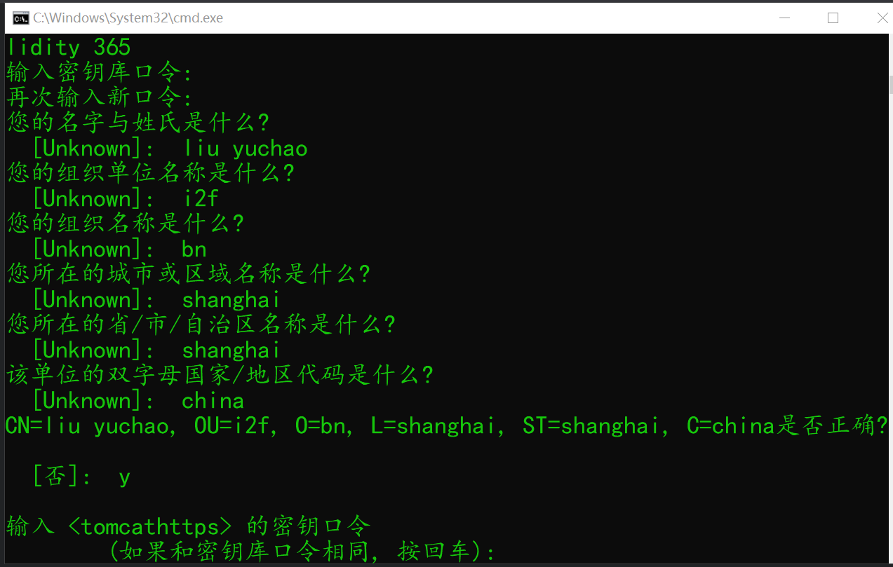

参考文章：

[https://mp.weixin.qq.com/s?\_\_biz=MzI1NDY0MTkzNQ==&mid=2247486160&idx=1&sn=2dd53840370ab6a69aa1e910fbce01d1&chksm=e9c358b0deb4d1a6a6d9b2d47b58da3a4a7483147ef84ba059a47d10d7efbc61bcdeff1e503a&scene=21#wechat\_redirect](https://mp.weixin.qq.com/s?__biz=MzI1NDY0MTkzNQ==&mid=2247486160&idx=1&sn=2dd53840370ab6a69aa1e910fbce01d1&chksm=e9c358b0deb4d1a6a6d9b2d47b58da3a4a7483147ef84ba059a47d10d7efbc61bcdeff1e503a&scene=21" \l "wechat_redirect)

一切都很顺利，只不过最后着地的时候是脸先着地的

折上折